**RPLidar C1 360 degree lidar[¶](https://ardupilot.org/copter/docs/common-rplidar-a2.html" \l "rplidar-c1-a2-and-s1-360-degree-lidar)**

* rotation rate: 8-15hz
* sample rate: 92000 samples/s
* range: 0.05m to 12m
* resolution: 0.39 degrees
* voltage/current requirement: 5V / 0.5A
* Communication Speed 460 800 !!!!!

**Connecting and Configuring[¶](https://ardupilot.org/copter/docs/common-rplidar-a2.html" \l "connecting-and-configuring)**

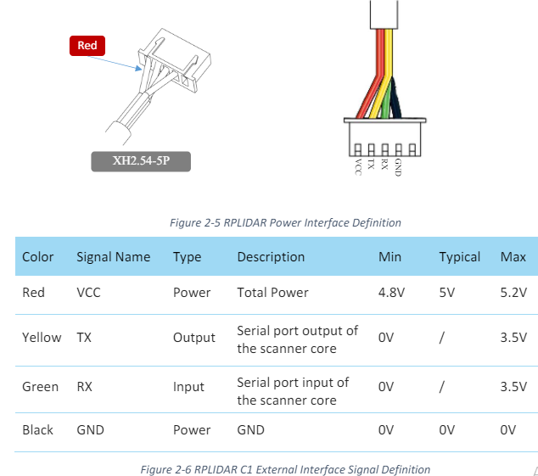

## UART pixhawk 6x Mapping[¶](https://ardupilot.org/plane/docs/common-holybro-pixhawk6X.html" \l "uart-mapping)

* SERIAL0 -> USB
* SERIAL1 -> UART7 (Telem1) RTS/CTS pins
* SERIAL2 -> UART5 (Telem2) RTS/CTS pins
* SERIAL3 -> USART1 (GPS1)
* SERIAL4 -> UART8 (GPS2)
* SERIAL5 -> USART2 (Telem3) RTS/CTS pins
* SERIAL6 -> UART4 (User)
* SERIAL7 -> USART3 (Debug)
* SERIAL8 -> USB (MAVLink, can be used for SLCAN with protocol change)

**C1:**

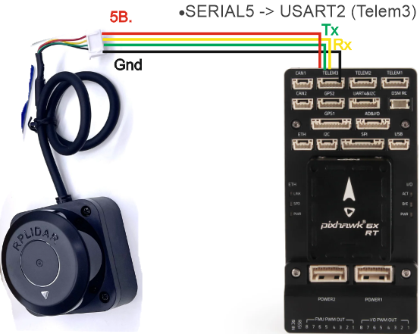

The lidar should be mounted horizontally on the top or bottom of the vehicle with the black cable pointing towards the rear of the vehicle. Ensure the sensor’s view is not obstructed by any portion of the vehicle including GPS mast, vehicle legs etc.

The lidar can be connected to the autopilot’s serial input as shown above. Be sure that the autopilot’s 5V supply is capable of supplying the unit’s required current. Otherwise provide an independent 5V supply to the unit.

Example setup below shown for first proximity sensor:

* [SERIAL5_PROTOCOL](https://ardupilot.org/copter/docs/parameters.html" \l "serial1-protocol) = “11” (“Lidar360”) if using Serial1
* [SERIAL5_BAUD](https://ardupilot.org/copter/docs/parameters.html" \l "serial1-baud) = “460” for C1/A2, “256” for S1,A2M12 if using Serial1
* [PRX1_TYPE](https://ardupilot.org/copter/docs/parameters.html" \l "prx1-type) = “5”
* [PRX1_ORIENT](https://ardupilot.org/copter/docs/parameters.html" \l "prx1-orient) = “0” if mounted on the top of the vehicle, “1” if mounted upside-down on the bottom of the vehicle.

It may be necessary to turn off flow control if using Telem1 (aka Serial1) or Telem2 (aka Serial2)

* [BRD_SER1_RTSCTS](https://ardupilot.org/copter/docs/parameters.html" \l "brd-ser1-rtscts) = “0” if using Serial1

More details on using this sensor for object avoidance on Copter can be found [here](https://ardupilot.org/copter/docs/common-object-avoidance-landing-page.html" \l "common-object-avoidance-landing-page).

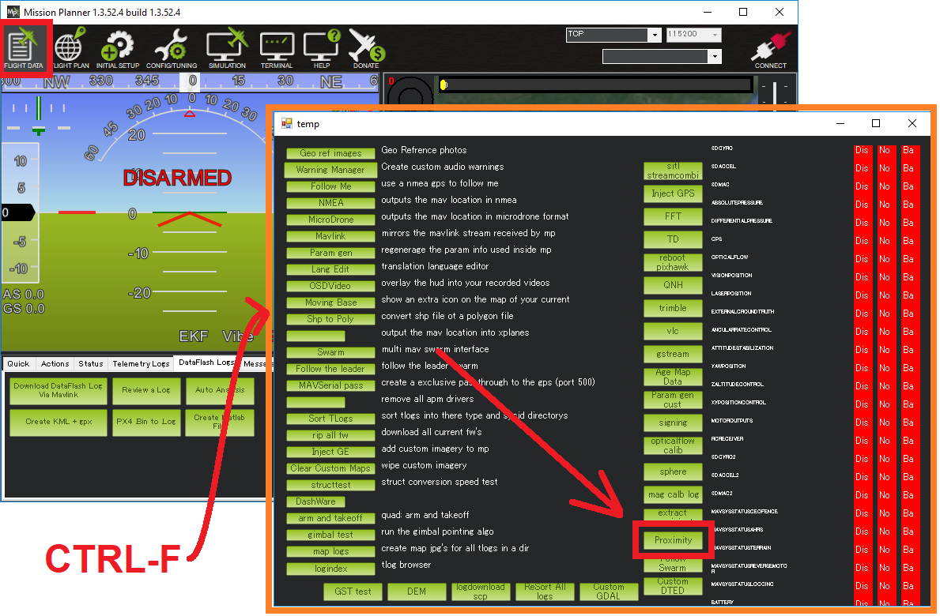

|  |
| --- |
| AVOID_BEHAVE |

1 - stop

|  |
| --- |
| AVOID_DIST_MAX |

3 m

|  |
| --- |
| AVOID_ENABLE |

